O’ZBEKISTON RESPUBLIKASI OLIY TA’LIM, FAN VA INNOVATSIYA VAZIRLIGI
ABU RAYXON BERUNIY NOMIDAGI URGANCH DAVLAT UNIVERSITETI

Kompyuter injineringgi fakulteti
„Kompyuter ilmlari va dasturlash texnologiyalari” yo’nalishi 234-guruh
Razzaqova Ro’zaxonning
“Web texnologiya ” fanidan
14-laboratoriya mashg’uloti

Qabul qildi: ________________________________________________

Urganch-2025

Labоratоriya ishi №14
Mavzu: Formani JavaScript orqali tekshirish (validation).
Nazariy qism
Form validation — bu forma yuborilishidan oldin foydalanuvchi kiritgan maʼlumotlarni to‘g‘ri yoki noto‘g‘ri ekanini tekshirish jarayoni.
Validationning maqsadi:
- Noto‘g‘ri ma’lumotning serverga ketishini oldini olish
- Xatoliklarni foydalanuvchiga ko‘rsatish
- Dastur xavfsizligini oshirish
- Foydalanuvchi bilan qulay ishlashni taʼminlash
Formalarda ishlatiladigan asosiy tekshiruvlar (validation turlari)
Validatsiya turi | Qanday tekshiriladi? | Misol
Bo‘sh qolmasligi (required) | Input bo‘sh emasligi | if(name === "")
Uzunlikni tekshirish | Minimal yoki maksimal belgilar soni | name.length >= 3
Email tekshiruvi | Regex orqali | /^\S+@\S+\.\S+$/
Telefon raqami format | Sonlar + uzunlik | /^\d{9}$/
Maxsus belgilarni tekshirish | Regex | /^[a-zA-Z]+$/
Password tekshirish | Minimal uzunlik + son + harf | /^(?=.*[A-Z])(?=.*\d).{6,}$/
JavaScript’da validation usullari
Manual validation
if(name === "") {
error("Ismni to‘ldiring");
}
Regex validation
let emailReg = /^\S+@\S+\.\S+$/;
if(!emailReg.test(email)) {
error("Email noto‘g‘ri");
}
event.preventDefault()
Formaning avtomatik yuborilishini to‘xtatish
form.addEventListener("submit", function(e){
e.preventDefault();
});
Amaliy qism.
Html kod.
<!DOCTYPE html>
<html lang="uz">
<head>
<meta charset="UTF-8">
<title>Form Validation – Xiva</title>
<style>
body {
margin: 0;
font-family: "Poppins", sans-serif;
background: linear-gradient(135deg, #8EC5FC, #E0C3FC);
height: 100vh;
display: flex;
justify-content: center;
align-items: center;
}
.card {
width: 450px;
background: #fff;
padding: 30px;
border-radius: 20px;
box-shadow: 0 12px 35px rgba(0,0,0,0.15);
animation: fadeIn 0.8s ease;
}
@keyframes fadeIn {
from { opacity: 0; transform: translateY(20px); }
to { opacity: 1; transform: translateY(0); }
}
h2 {
text-align: center;
margin-bottom: 20px;
color: #333;
}
label {
font-weight: 600;
}
input, textarea {
width: 100%;
padding: 12px;
margin-top: 8px;
border-radius: 10px;
border: 2px solid #ccc;
font-size: 15px;
transition: 0.3s;
}
input:focus, textarea:focus {
border-color: #8EC5FC;
box-shadow: 0 0 8px #8EC5FC;
}
.error {
border-color: red !important;
}
.success {
border-color: #10c44c !important;
}
.err-msg {
font-size: 13px;
color: red;
margin-top: 5px;
}
button {
width: 100%;
background: #8a63da;
color: white;
padding: 12px;
border: none;
border-radius: 12px;
font-size: 17px;
margin-top: 12px;
cursor: pointer;
transition: 0.3s;
}
button:hover {
background: #6f4bc5;
transform: scale(1.03);
}
#result {
margin-top: 15px;
padding: 12px;
background: #eaffea;
border-left: 5px solid #10c44c;
border-radius: 10px;
display: none;
}
</style>
</head>
<body>
<div class="card">
<h2>Xiva bo‘yicha fikr — Forma Tekshiruvi</h2>
<form id="xivaForm">
<label>Ismingiz:</label>
<input type="text" id="name">
<div class="err-msg" id="nameError"></div>
<label>Email:</label>
<input type="text" id="email">
<div class="err-msg" id="emailError"></div>
<label>Xiva haqida fikringiz:</label>
<textarea id="comment" rows="4"></textarea>
<div class="err-msg" id="commentError"></div>
<button type="submit">Yuborish</button>
</form>
<div id="result"></div>
</div>
<script>
document.getElementById("xivaForm").addEventListener("submit", function(e){
e.preventDefault();
let name = document.getElementById("name");
let email = document.getElementById("email");
let comment = document.getElementById("comment");
let nameErr = document.getElementById("nameError");
let emailErr = document.getElementById("emailError");
let commentErr = document.getElementById("commentError");
let valid = true;
if(name.value.trim() === ""){
name.classList.add("error");
nameErr.innerText = "Ismni kiriting!";
valid = false;
} else {
name.classList.add("success");
name.classList.remove("error");
nameErr.innerText = "";
}
let emailReg = /^\S+@\S+\.\S+$/;
if(!emailReg.test(email.value)){
email.classList.add("error");
emailErr.innerText = "Email noto‘g‘ri formatda!";
valid = false;
} else {
email.classList.add("success");
email.classList.remove("error");
emailErr.innerText = "";
}
if(comment.value.length < 5){
comment.classList.add("error");
commentErr.innerText = "Kamida 5 ta belgi kiriting!";
valid = false;
} else {
comment.classList.add("success");
comment.classList.remove("error");
commentErr.innerText = "";
}
if(valid){
document.getElementById("result").style.display = "block";
document.getElementById("result").innerText =
"Rahmat! Fikringiz qabul qilindi: " + comment.value;
}
});
</script>
</body>
</html>
Kodni natijasi.
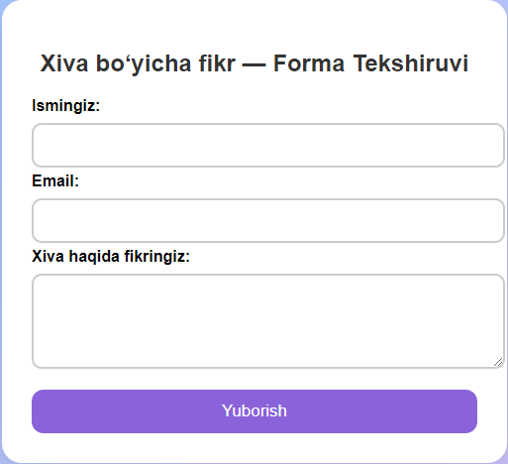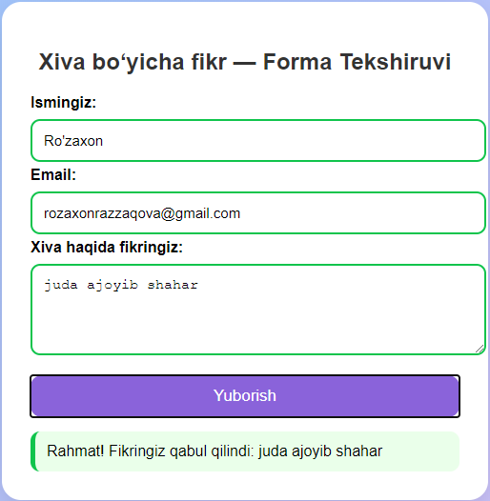
Xulosa.
Ushbu laboratoriya ishida web sahifalarda forma orqali kiritiladigan ma’lumotlarni JavaScript yordamida tekshirish (validation) jarayoni o‘rganildi. Kiritilgan ism, email va matn bo‘sh emasligi, formatga mosligi va minimal uzunligi tekshirildi. Notog‘ri kiritilgan maʼlumotlar foydalanuvchiga rangli ko‘rsatkichlar (qizil — xato, yashil — to‘g‘ri) orqali ifodalandi. Ushbu amaliyot web dasturlarda ma’lumotlar to‘g‘ri kelishini ta’minlashda juda muhim hisoblanadi.

